SE489 DevOps Engineering

Lab 6

# Lab 6: Docker

Objectives: After the successful completion of this lab, user will be able understand, install, and use Docker and port Docker images and containers.

Installation of Docker on Windows Machine (64 bit architecture)

## Installing and Running Docker

1. Search Google for docker installer for windows  
   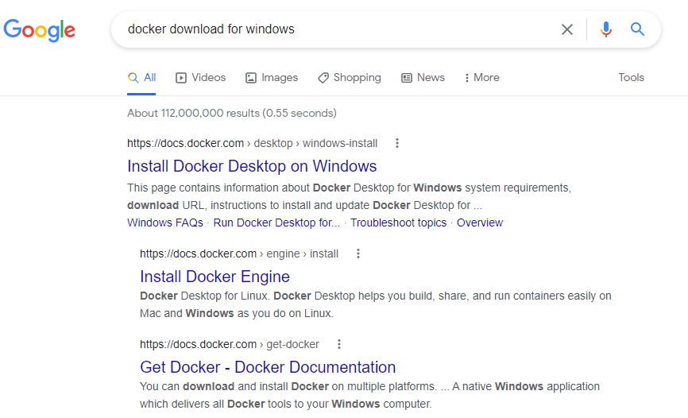
2. First link takes to home page for the Docker download   
   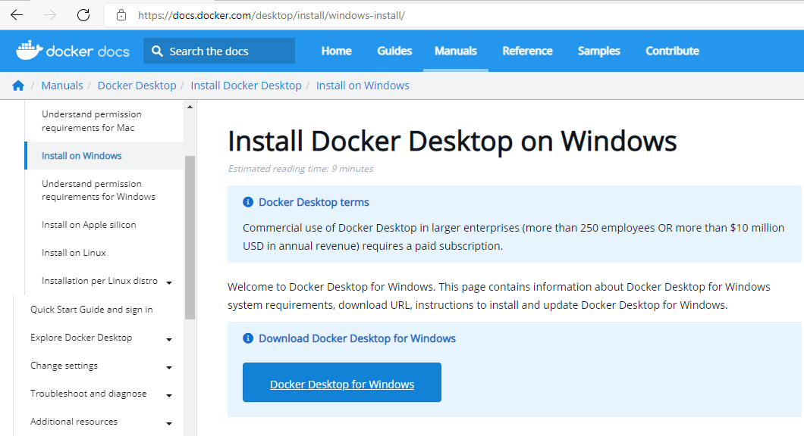

Click on *Docker Desktop for Windows*, automatic download will start.

1. Right Click on the Docker Installer, and choose Run as administrator,  
   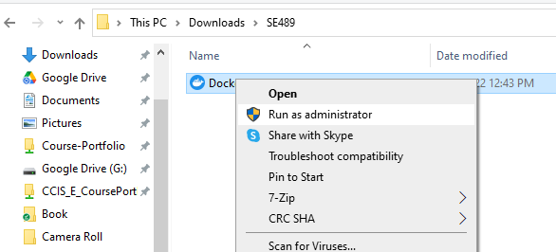
2. Accept these recommendations  
   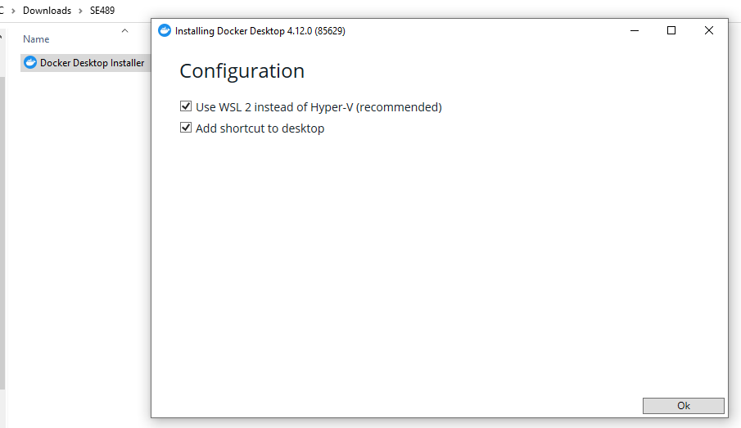  
   Docker installation begins with unpacking of various installation files  
   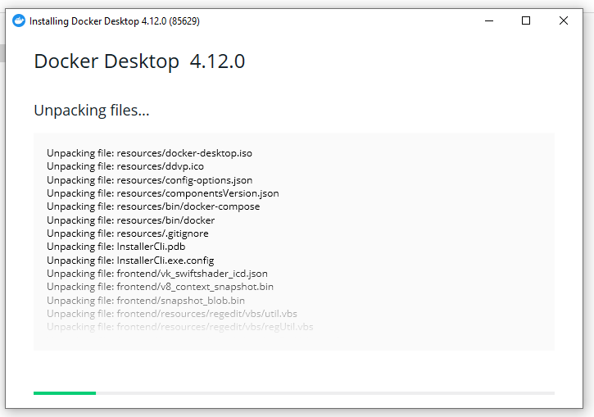
3. When prompted click on Close and restart  
   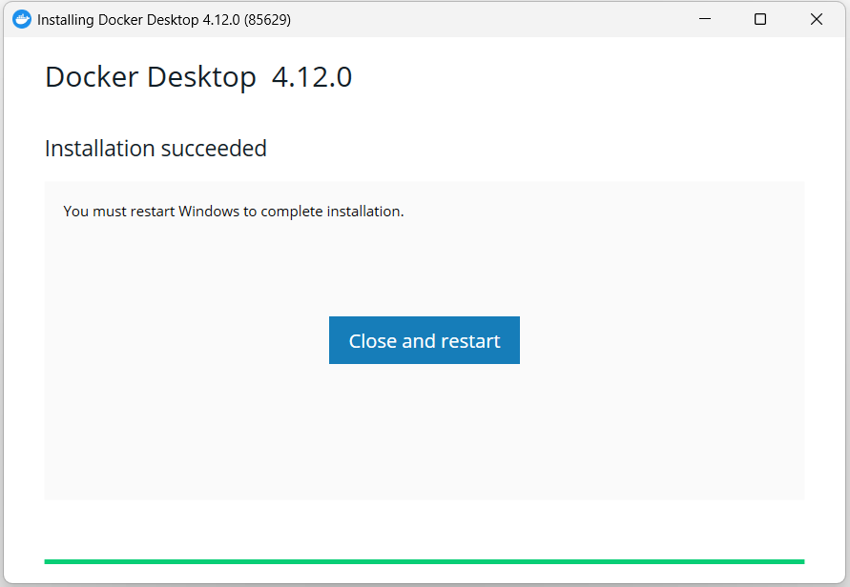
4. Upon restart, it will ask for accepting Docker Subscription Service Agreement, accept them



1. After this, following screen will appear

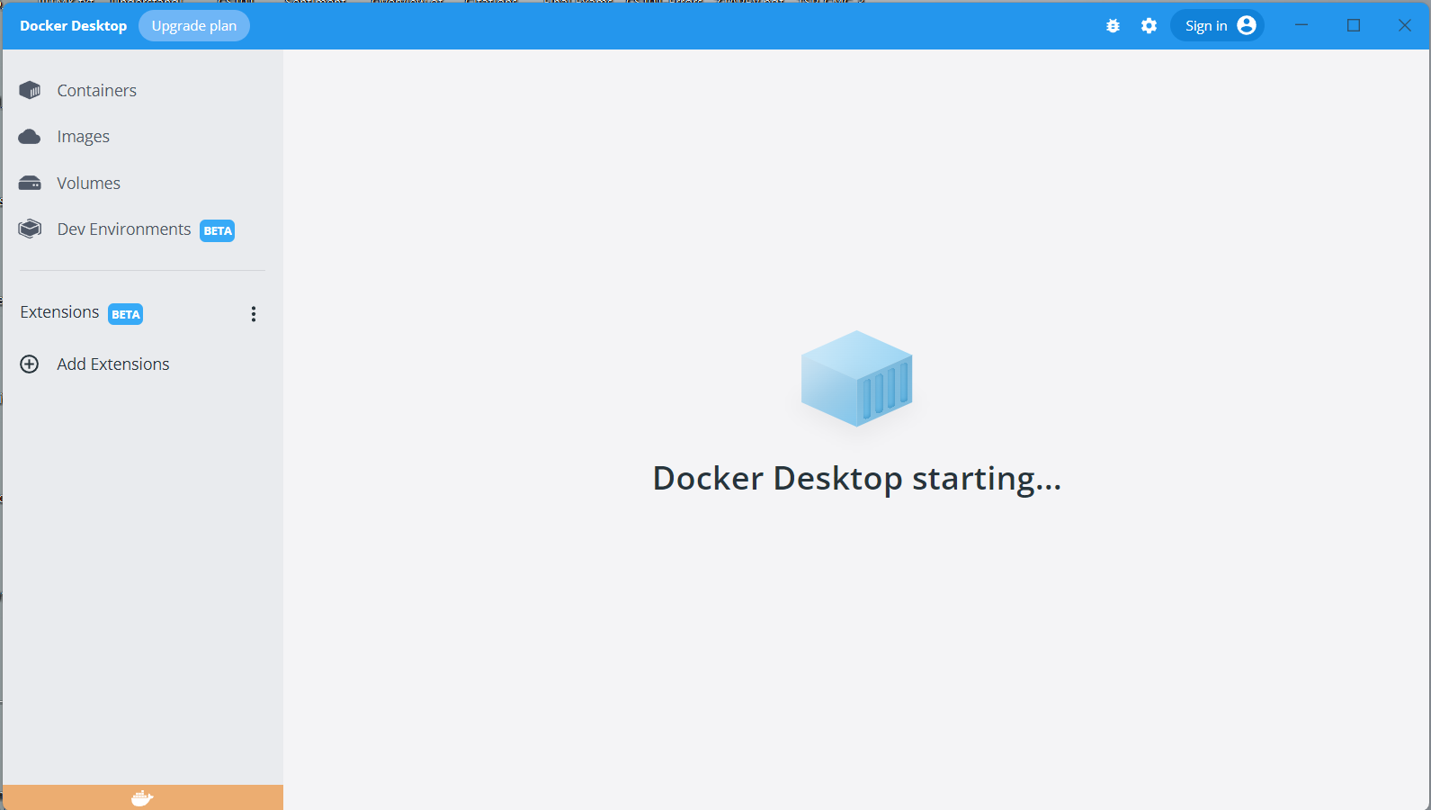

Once finished, System Tray will display whale icon of Docker  
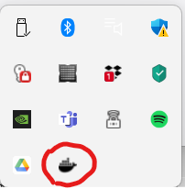

1. This is home screen of the Docker

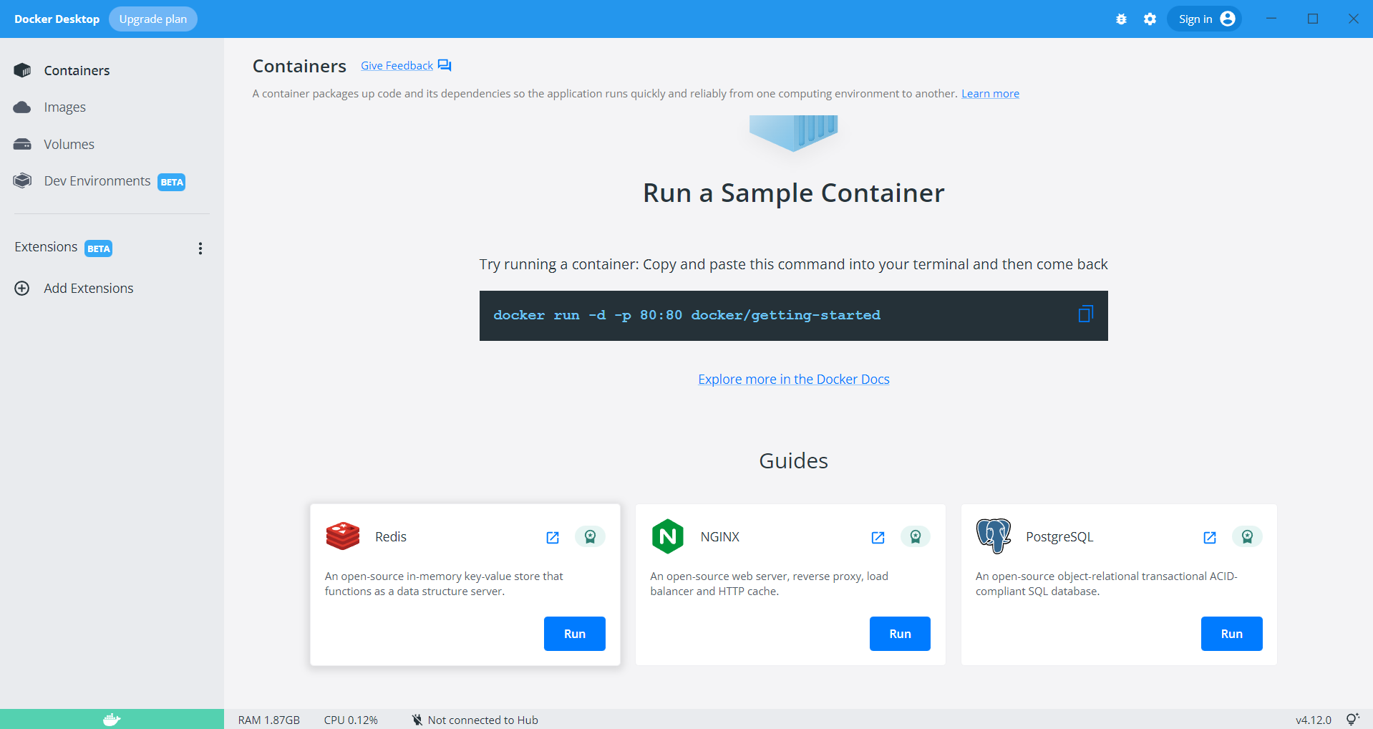

1. Copy the presented command from the Docker interface and open Command Prompt on your window machine, paste the command and press Enter, since we don’t have any docker image, this command first looks locally and prompts ‘Unable to find image…’ and then downloads it from docker repository

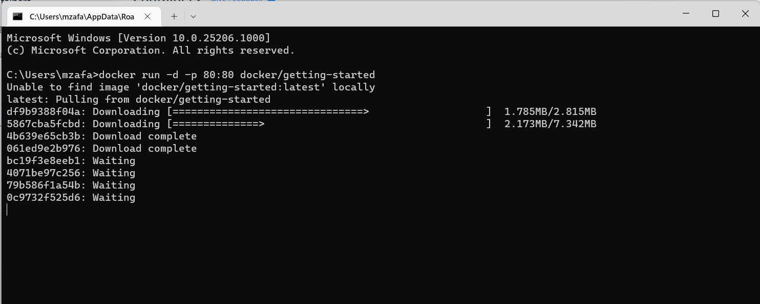

After downloading image, it’s screen will look like this

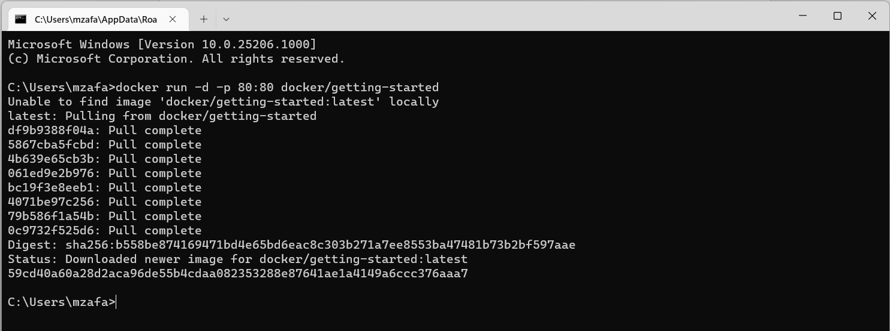

1. Since we copied and executed getting-started image from Docker’s repository, it is now visible at home screen of Docker.

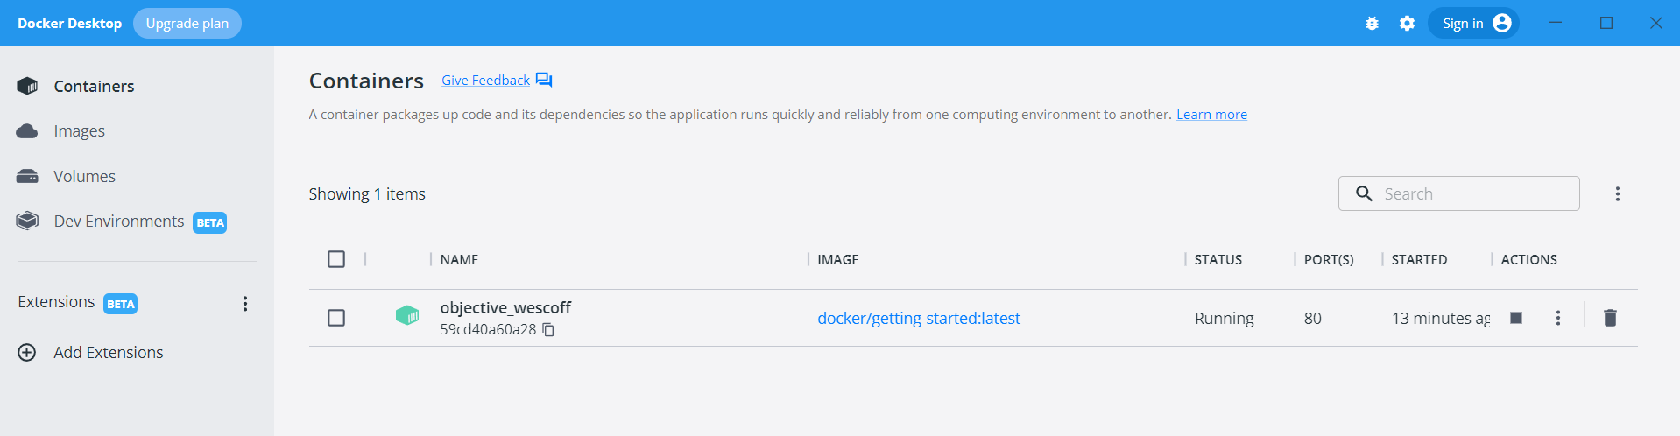

1. There are some Docker customization options also available, click on the setting option available on the top right side of the Docker interface, make required changes and click on *Apply & Restart*

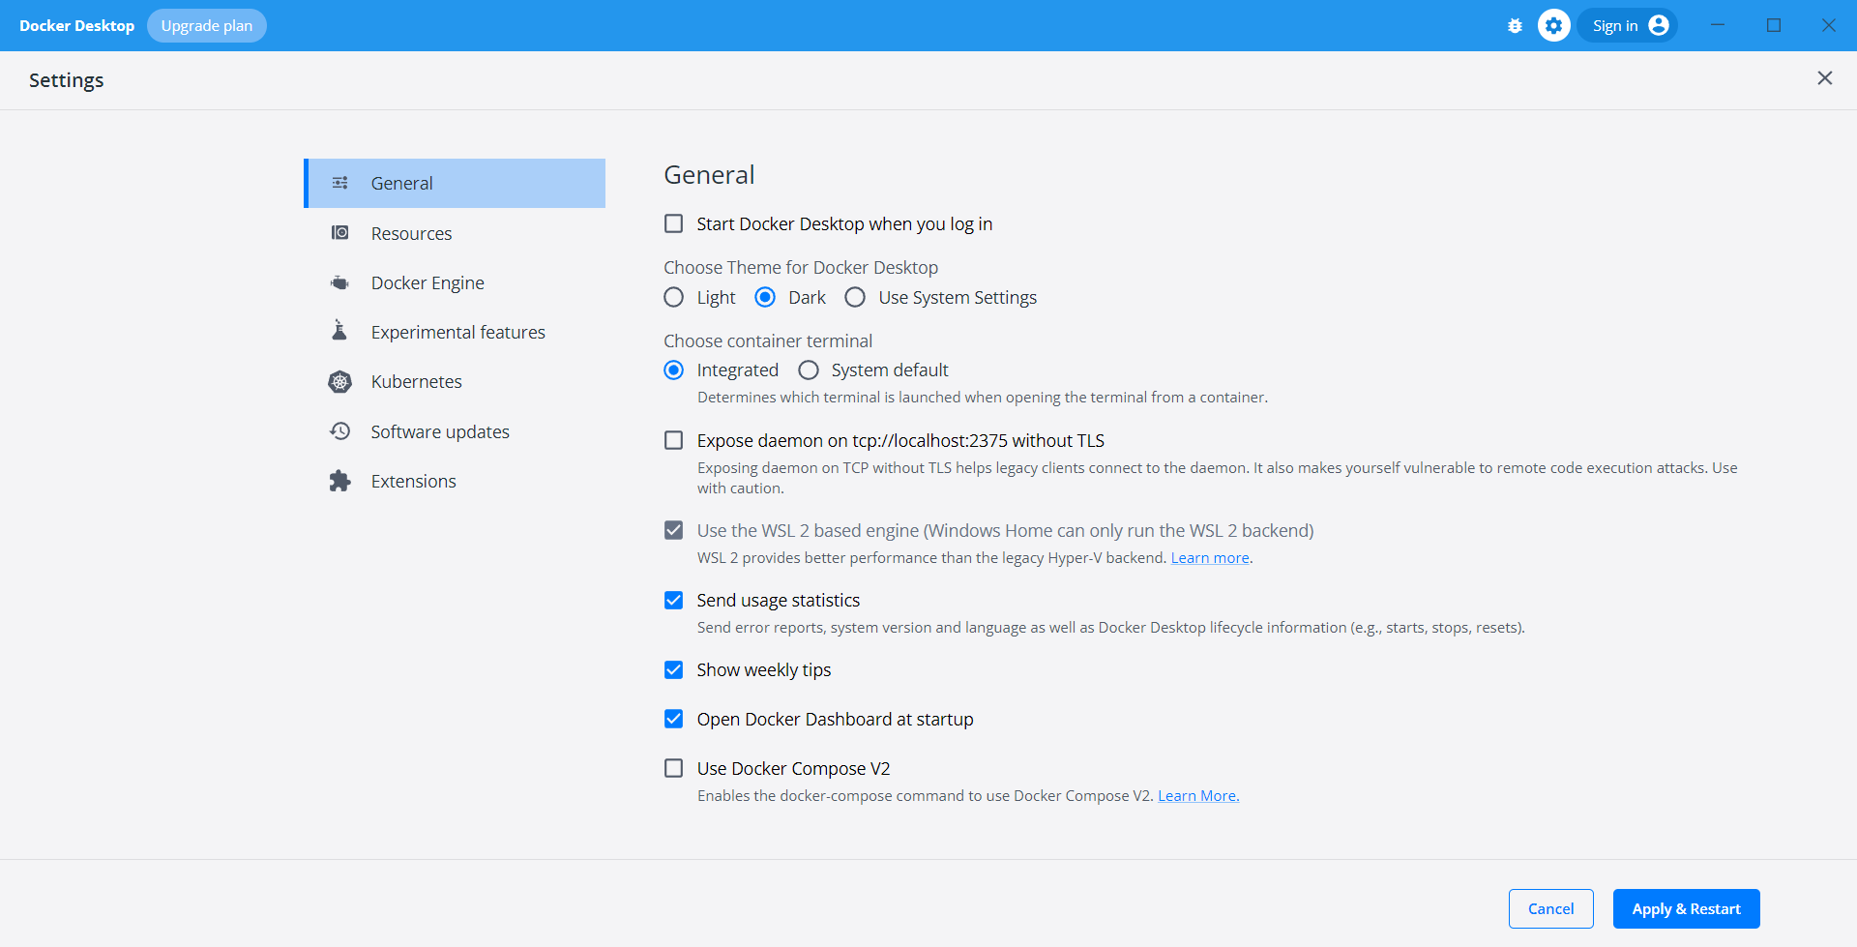

## More Docker Commands

1. Open command prompt and run command, 🡺**docker ps**  
   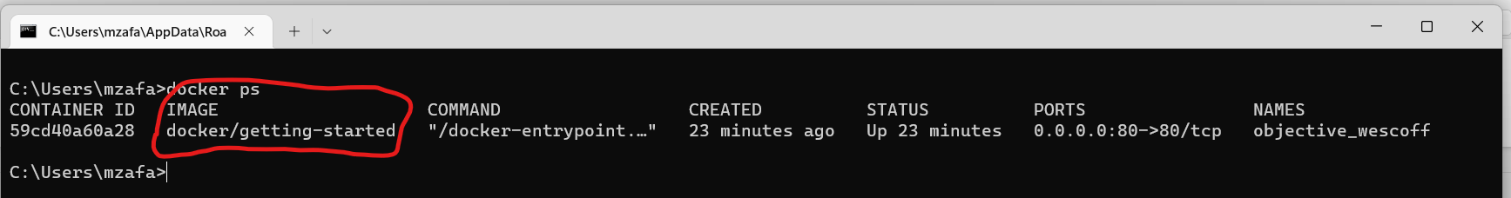it lists all the running images available in the system
2. Now lets, pull some other images from the Docker repository, run command, 🡺 **docker pull hello-world**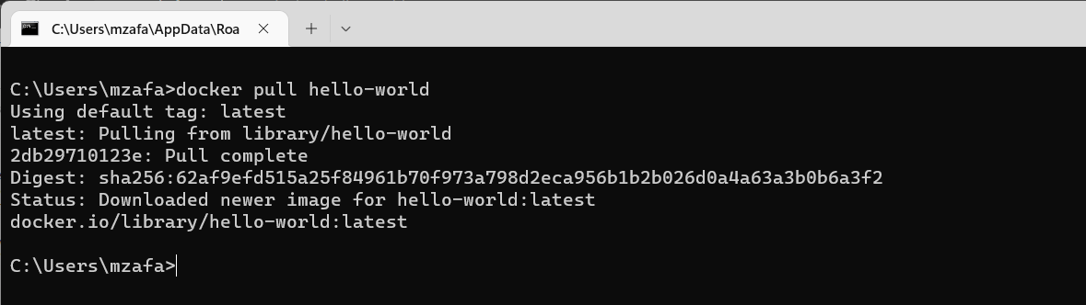

Docker pull command, downloads hello-world image from Docker repository (also known as Docker hub) into local machine.

1. Run the newly pulled image with this command,

🡺**docker run hello-world**   
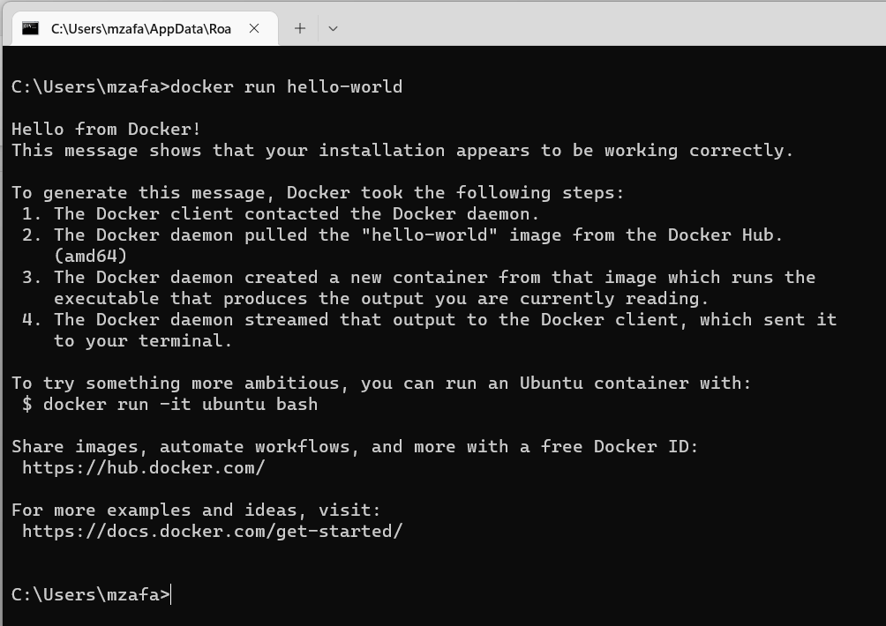

Message, appeared shows, we have successfully downloaded an image from the Docker Hub and ran it’s container.

1. Let’s check number of containers through **docker ps -a** command

